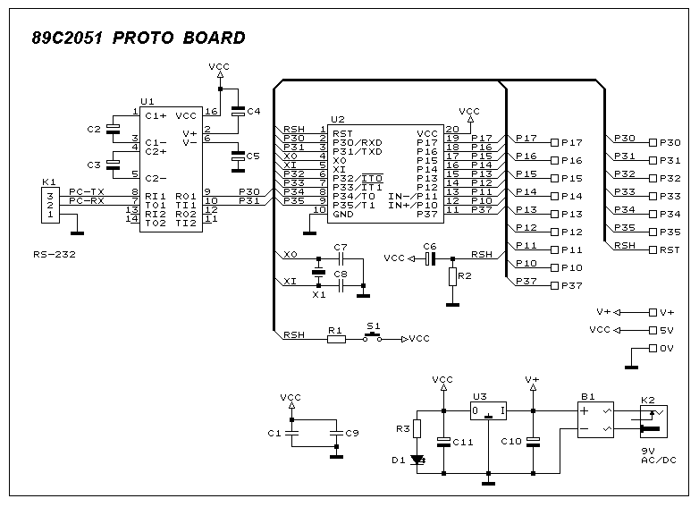
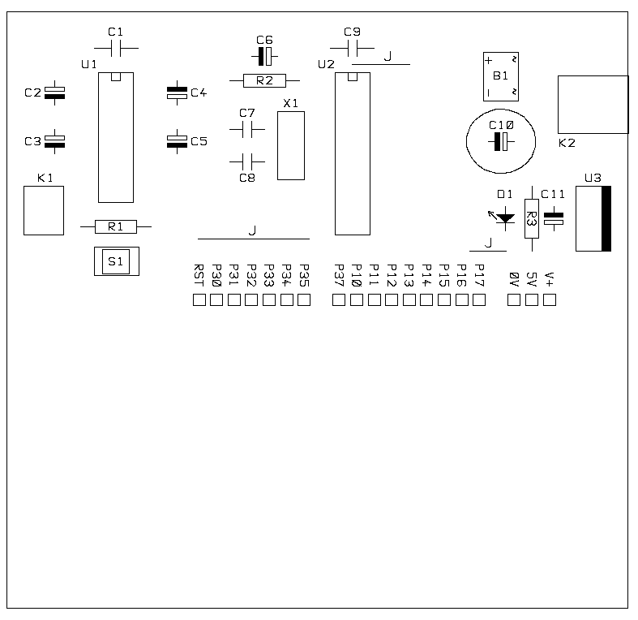
Part List of the Project.
1 1 B1 BRIDGE 100V 1A (DIP TYPE)
2 2 C1,C9 100nF CERAMIC
3 6 C2,C3,C4,C5,C6,C11 10uF 16V
4 2 C7,C8 33pF CERAMIC
5 1 C10 470uF 25V
6 1 D1 LED GREEN 3mm
7 1 K1 SIP CON 3 WAY
8 1 K2 DC SOCKET (PCB TYPE)
9 1 R1 100R
10 1 R2 10K
11 1 R3 560R
12 1 S1 PUSH SWITCH
13 1 U1 MAX232
14 1 U2 AT89Cx051, AT90S1200, AT90S2313
15 1 U3 LM7805
16 1 X1 CRYSTAL or CERAMIC RESONATOR

